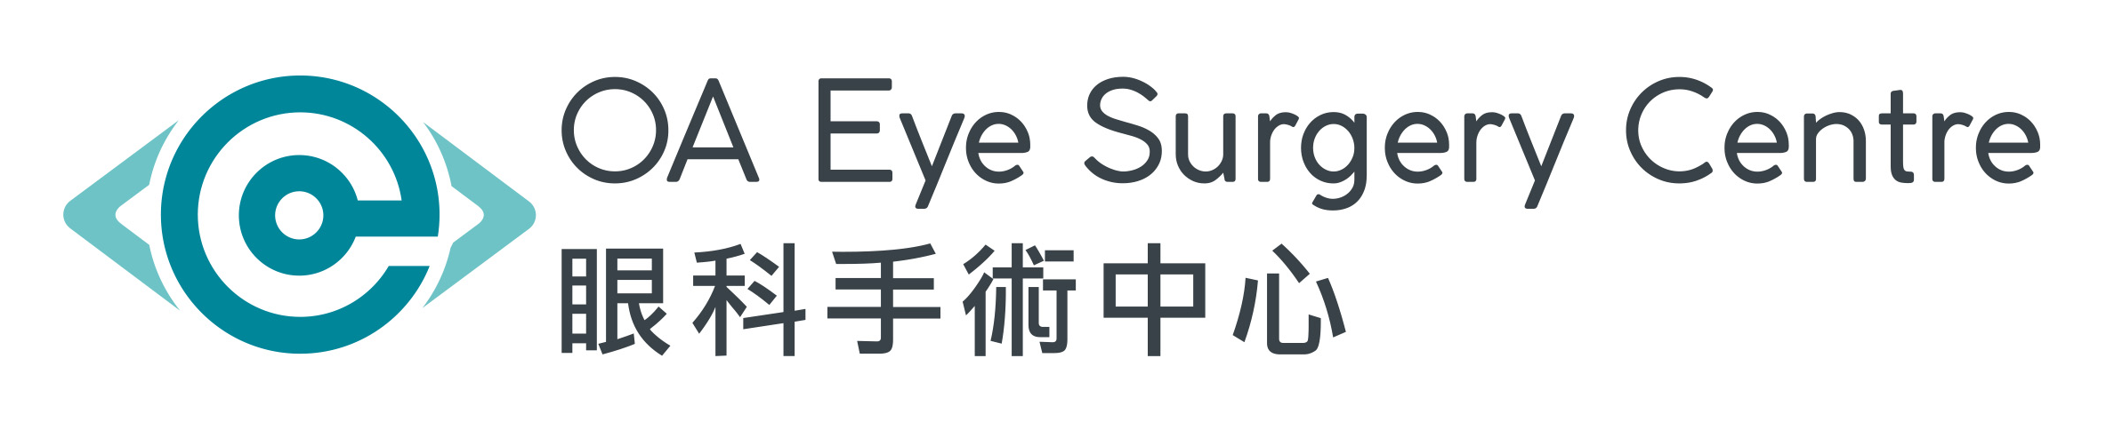

Consent for Pterygium Excision Surgery

I, (The Patient), hereby voluntarily give my consent to undergo the procedure of
Right / Left / Both Eye(s) Pterygium Excision Surgery
to be performed by Dr. under local anesthesia.

OR

I, , the father/ mother/ relative/ guardian of (The Patient),
hereby voluntarily give my consent for the patient to undergo the procedure of
Right / Left / Both Eye(s) Pterygium Excision Surgery
to be performed by Dr. under local anesthesia.

Possible risks and complications of pterygium excision surgery and local anesthesia

-
Must be read in conjunction with Notification for Pterygium Excision Surgery

Signature for confirmation of having received the Notification mentioned above:________________

Remarks: The list of complications and risks is not exhaustive. Other unforeseen complications may occasionally
occur. The actual risks may be different for different individuals, death may occur as a result.

I (the undersigned) have read and fully understand the contents of this consent and Notification for Pterygium
Excision Surgery. All of the information and my related questions, including but not limited to the nature,
purpose, risk and possible complications of this operation, were being explained and answered, and I totally understood. I also consent to further or alternative operation measures as may be found to be necessary or advisable during the course of such procedure. I understand that by necessity, medical practitioners other than the Doctor may assist in performing this operation. I totally accept all the contents of this consent and notification.

Patient’s Signature
ID/Passport No:
Date: (dd/mm/yy)

Parent/Relative/Guardian’s
Name & Signature
ID/Passport No:
Relationship:
Date: (dd/mm/yy)

Signature of Witness
Witness’s Name:
Witness (if any) – Staff Rank /Relationship with Patient
Date: (dd/mm/yy)

DOCTOR’S DECLARATION: I have explained the nature, risks and benefits of the operation to the patient/
individual signed above and have answered their questions. To the best of my knowledge, the patient/
individual signed above has been adequately informed and has consented, and the details as such had been
documented in the patient’s clinical record.

Doctor’s Name Doctor’s Signature Date (dd/mm/yy)

Please contact your ophthalmologist for any enquiries

Notification for Pterygium Excision Surgery

Nature and purpose of the pterygium excision surgery
The pterygium is excised and adjunctive procedures may be performed when necessary to prevent
re-growth of pterygium. The adjunctive procedure includes conjunctival autograft and adjunctive
use of anti-metabolite and anti-fibrotic agents.

Possible risks and complications of the pterygium excision surgery
Pterygium excision operation is an operation with few complications. The most common
complication is the recurrence of pterygium. In some instances, the size of which could be bigger
than before. Other complications that may occur include:

-
-
-
-
-
-
-
-
-
Redness, watering and gritty sensation of the eye especially when stitches were placed
Granulation tissue formation of the wound
Astigmatism caused by scarring of the wound
Blurring of vision due to scarring. Vision may be worse than before
Adhesion between the eyeball and lid(s)
Ocular movement deficit causing squint and double vision
Ocular perforation
Wound infection or inflammation
Regional corneal-scleral melting

Risks of anesthesia
Anaphylactic drug reactions, redness, swelling, pain, bleeding or infection at areas under anesthesia or
injection sites may occur.

Remarks
The list of complications and risks is not exhaustive. Other unforeseen complications may occasionally occur.
The actual risks may be different for different individuals, death may occur as a result.

Please contact your ophthalmologist for any enquiries.

Source of Information: Hospital Authority
Hong Kong Ophthalmologic Society

Notification for Pterygium Excision Surgery

Patient Signature:

